Task on S3
1. Create an S3 bucket and upload some objects to S3.

STEP1: Create an S3 Bucket
- Login to AWS Console.
- Go to Amazon S3.
- Click Create bucket.
- Enter the following details:
- Bucket name: my-demo-s3-bucket-123
(Bucket name must be globally unique)
- Region: Choose a region (for example Asia Pacific – Hyderabad)
- Keep the default settings:
  - Block Public Access ✔️
  - Versioning ❌ (optional)
- Click Create bucket.
✅ Your S3 bucket is now created.

STEP 2.Upload Objects to the Bucket
- Open the bucket you created.
- Click Upload.
- Click Add files.
- Select files from your computer (example: file1.txt, image.png, data.csv).
- Click Upload.
✅ Files are now stored in your S3 bucket.
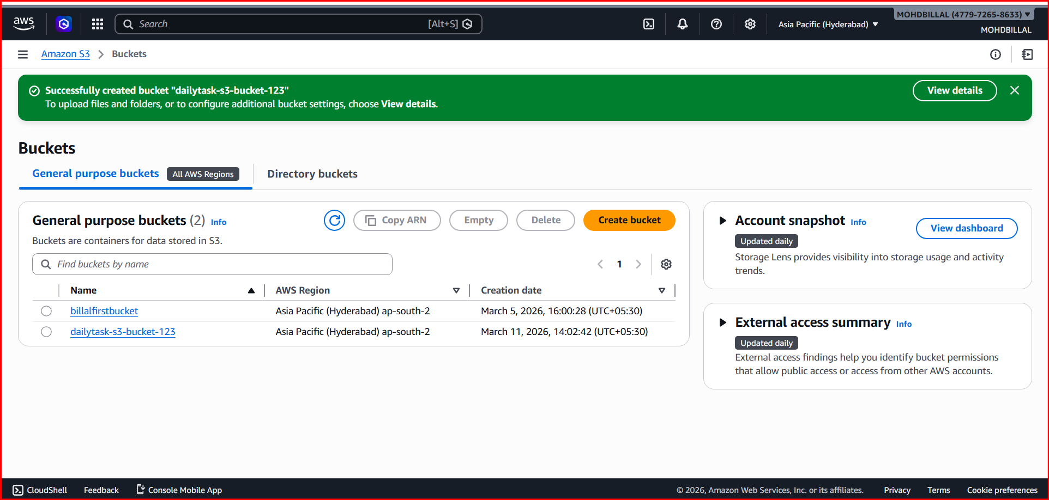

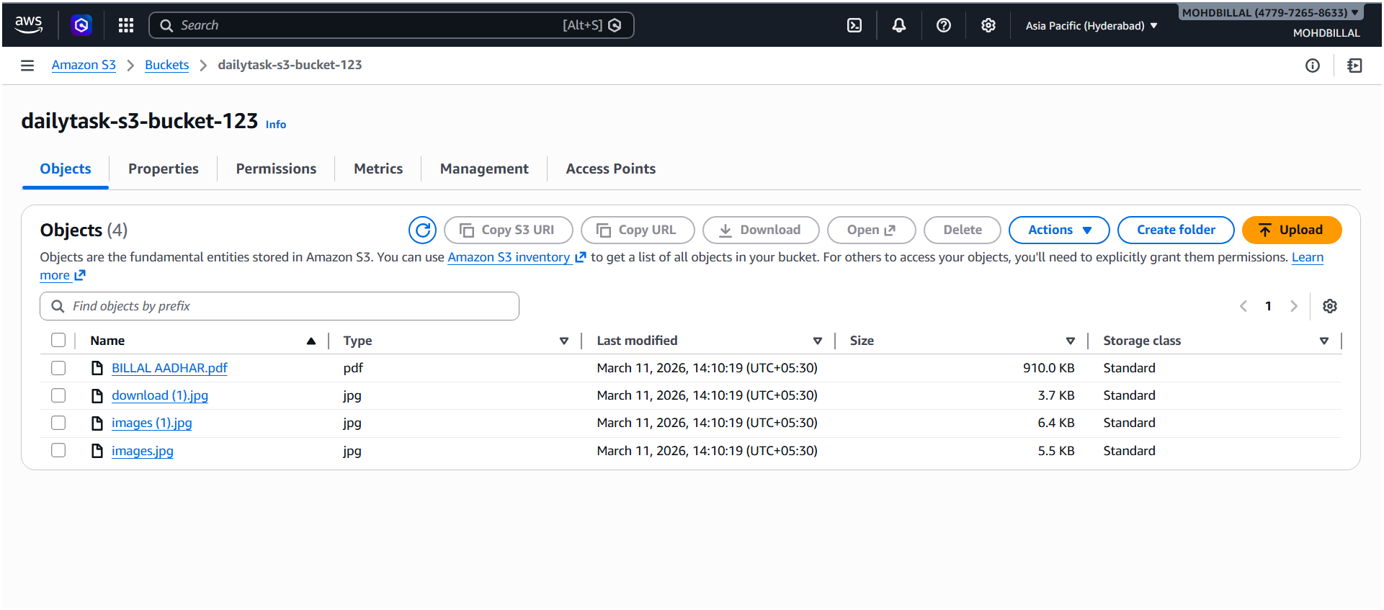
2. Deploy a static website in the S3 bucket.

STEP:1 Create an S3 Bucket
- Login to AWS Console.
- Go to Amazon S3.
- Click Create bucket.
- Enter:
- Bucket name: my-static-website-demo-123
- Region: Choose your nearest region.
⚠️ Important:
Uncheck Block all public access (because a website must be public).
- Accept the warning.
- Click Create bucket.

STEP:2 Upload Website Files
Create two files on your computer.

index.html
<html>
<head>
<title>My Static Website</title>
</head>
<body>
<h1>Welcome to My S3 Static Website</h1>
<p>This website is hosted on Amazon S3.</p>
</body>
</html>

error.html
<html>
<body>
<h1>Error Page</h1>
<p>Something went wrong.</p>
</body>
</html>
Upload them:
- Open your bucket.
- Click Upload.
- Upload:
  - index.html
  - error.html

STEP:3 Enable Static Website Hosting
- Open your bucket.
- Go to Properties tab.
- Scroll to Static website hosting.
- Click Edit.
- Enable:
Enable Static Website Hosting
- Enter:
Index document: index.html
Error document: error.html
- Save changes.

STEP: 4 Add Bucket Policy (Make Files Public)
Go to Permissions → Bucket Policy and add:
{
"Version": "2012-10-17",
"Statement": [
{
"Sid": "PublicRead",
"Effect": "Allow",
"Principal": "*",
"Action": "s3:GetObject",
"Resource": "arn:aws:s3:::my-static-website-demo-123/*"
}
]
}
Click Save.

STEP:5 Access the Website
After enabling hosting, S3 gives a website endpoint URL like:
http://my-static-website-demo-123.s3-website-ap-south-1.amazonaws.com
Open it in your browser.
✅ Your static website is now live.
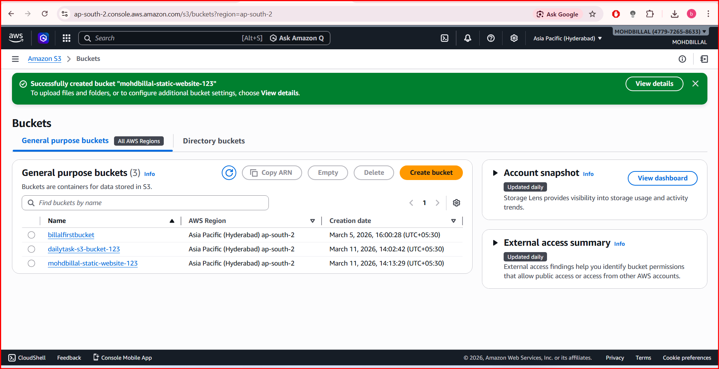
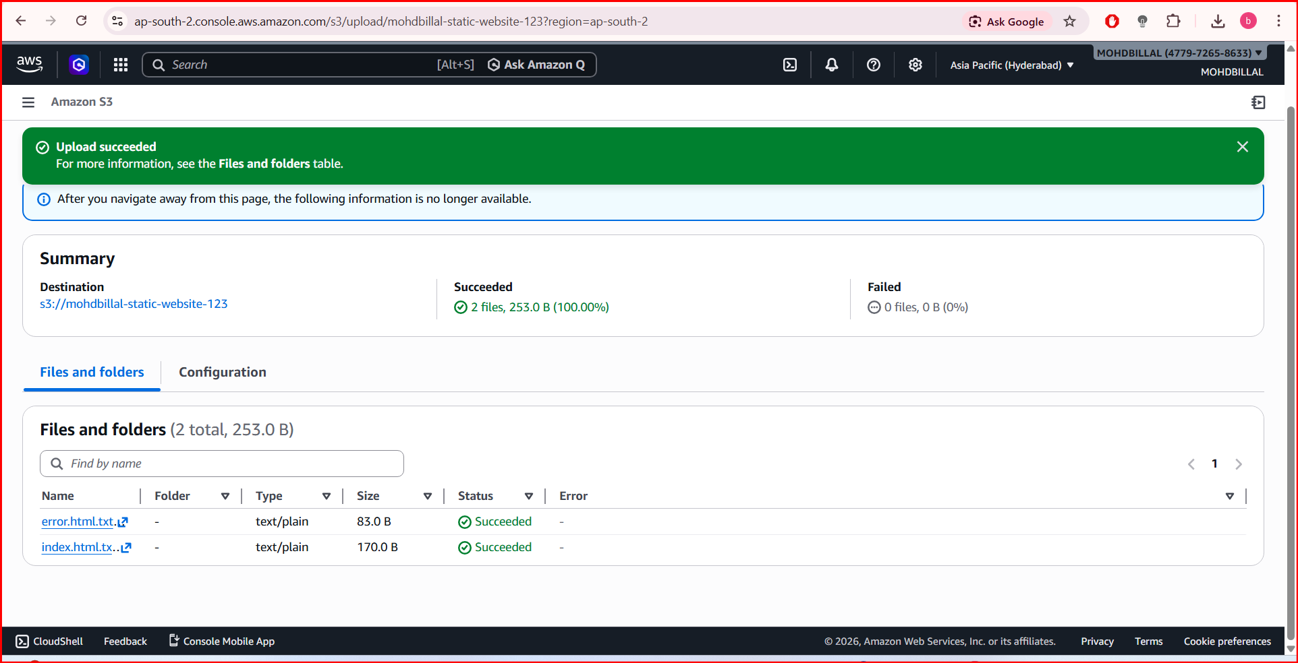
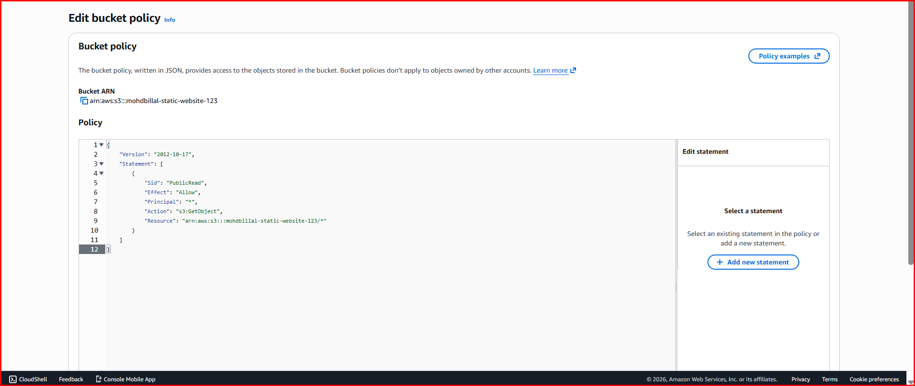
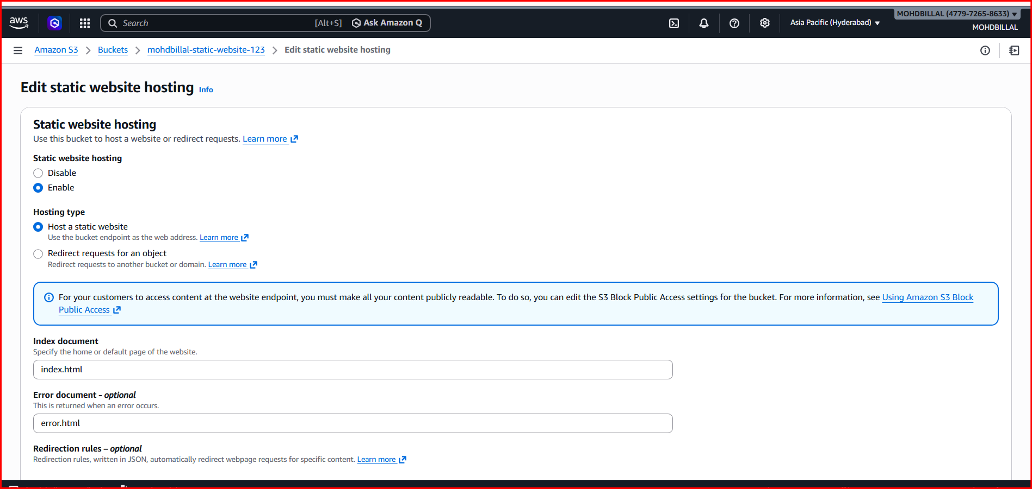
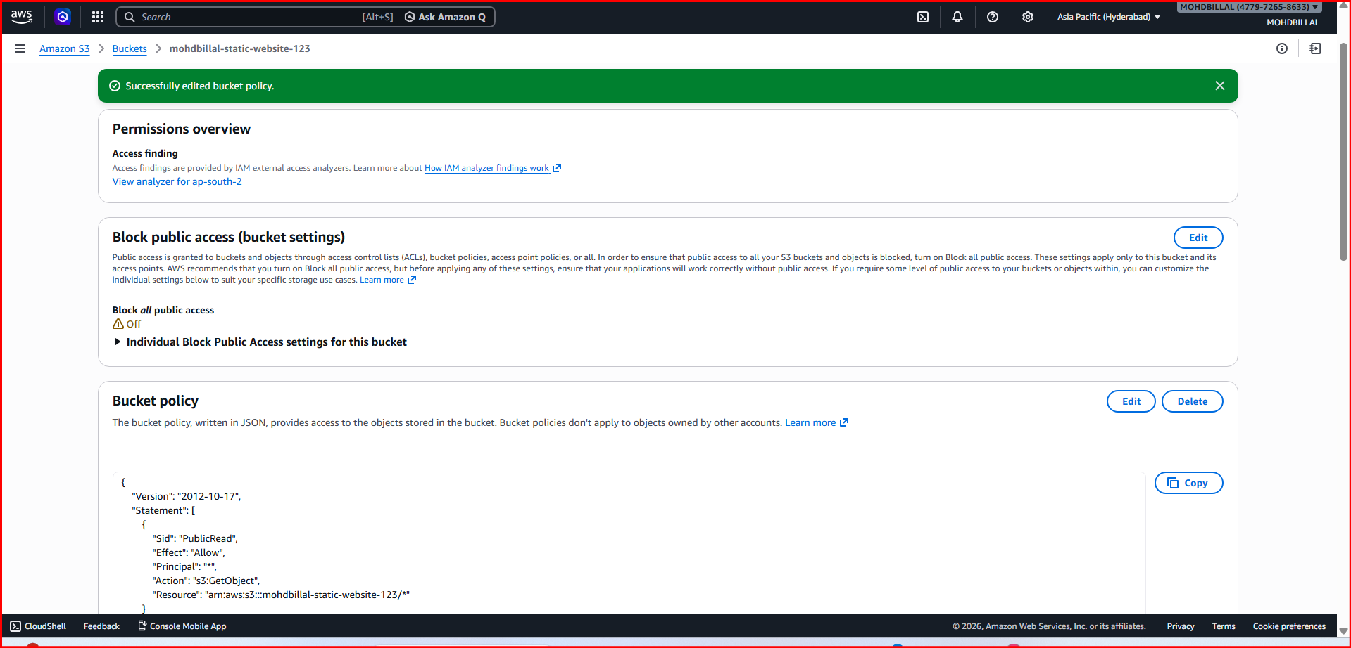

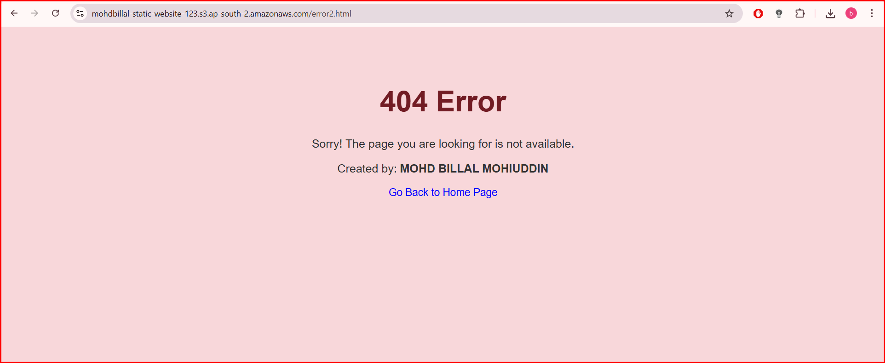
3. Enable cross-region replication on S3 buckets.

Steps to Enable Cross-Region Replication (CRR)

STEP:1.Create Two S3 Buckets in Different Regions
Go to Amazon S3 and create:
Bucket | Region | Purpose
source-bucket-demo-123 | ap-south-1 (Mumbai) | Source
destination-bucket-demo-123 | us-east-1 (N. Virginia) | Destination
⚠️ Bucket names must be globally unique.

STEP:2.Enable Versioning on Both Buckets
Replication requires versioning.
- Open source bucket
- Go to Properties
- Find Bucket Versioning
- Click Enable
Repeat the same for the destination bucket.

STEP:3. Create a Replication Rule
- Open source bucket
- Go to Management tab
- Click Replication rules
- Click Create replication rule
Enter:
Rule name
cross-region-replication-rule
Rule scope
Apply to all objects in the bucket

STEP:4 Select Destination Bucket
Choose:
destination-bucket-demo-123
Region:
us-east-1

STEP:5 Configure IAM Role
Replication requires permissions from AWS Identity and Access Management.
Choose:
Create new IAM role
AWS automatically creates the role for replication.

STEP:6 Save the Replication Rule
Click Save.
Now the replication configuration will be active.

STEP 7.Test the Replication
Upload a file to the source bucket:
testfile.txt
After a few seconds/minutes:
Check the destination bucket.
You will see the same file replicated automatically.
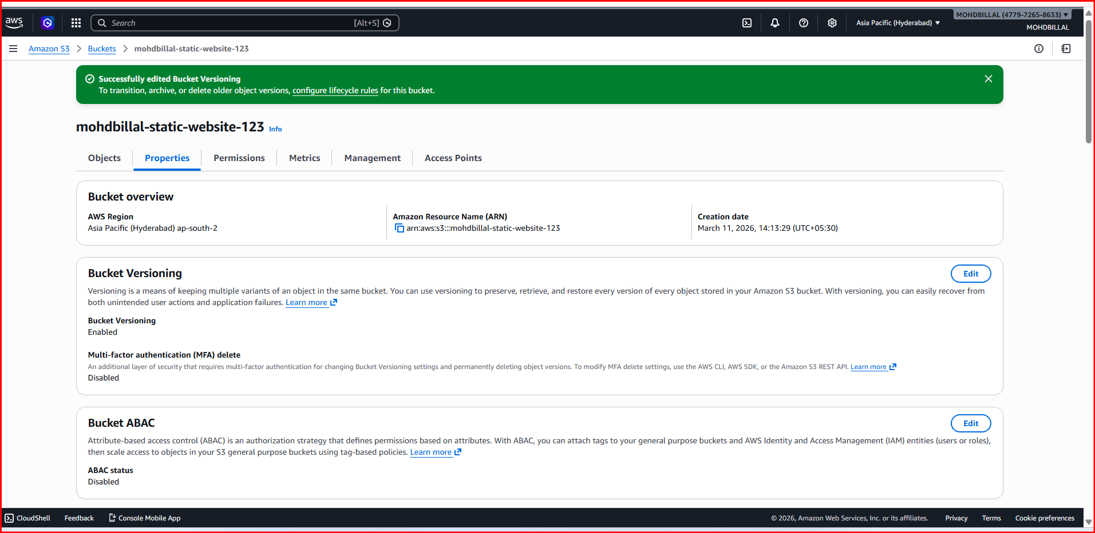
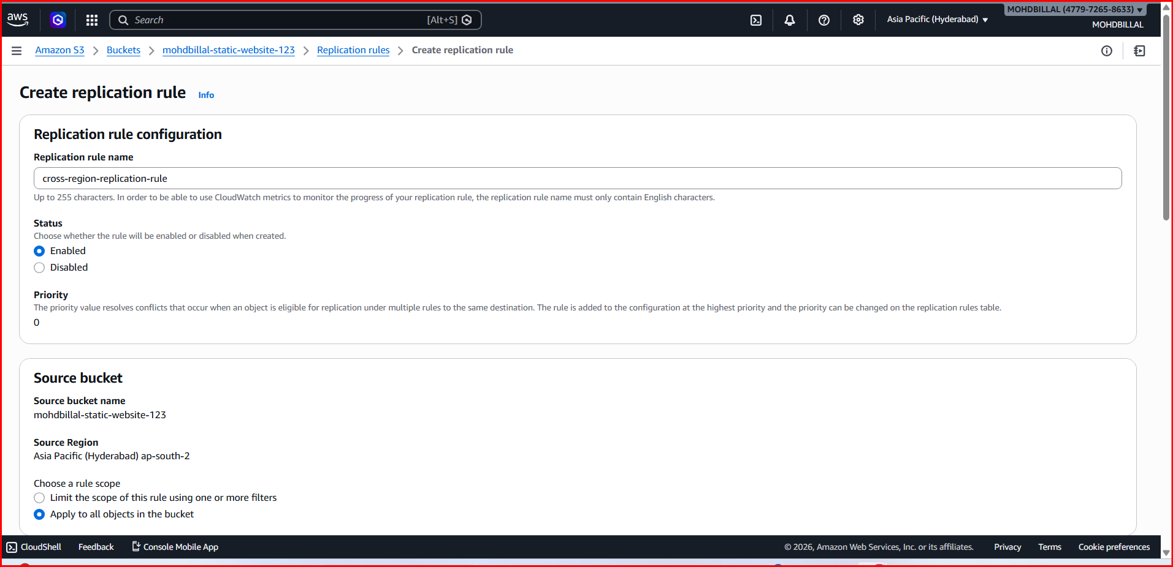
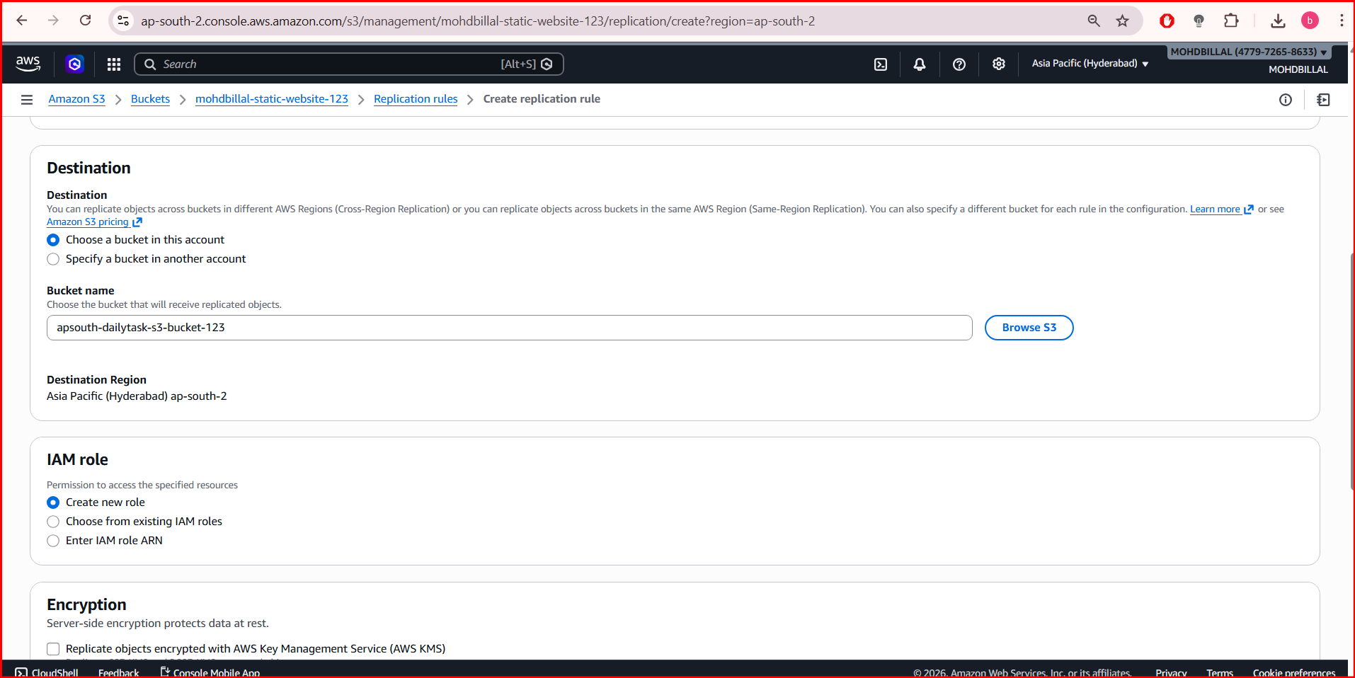
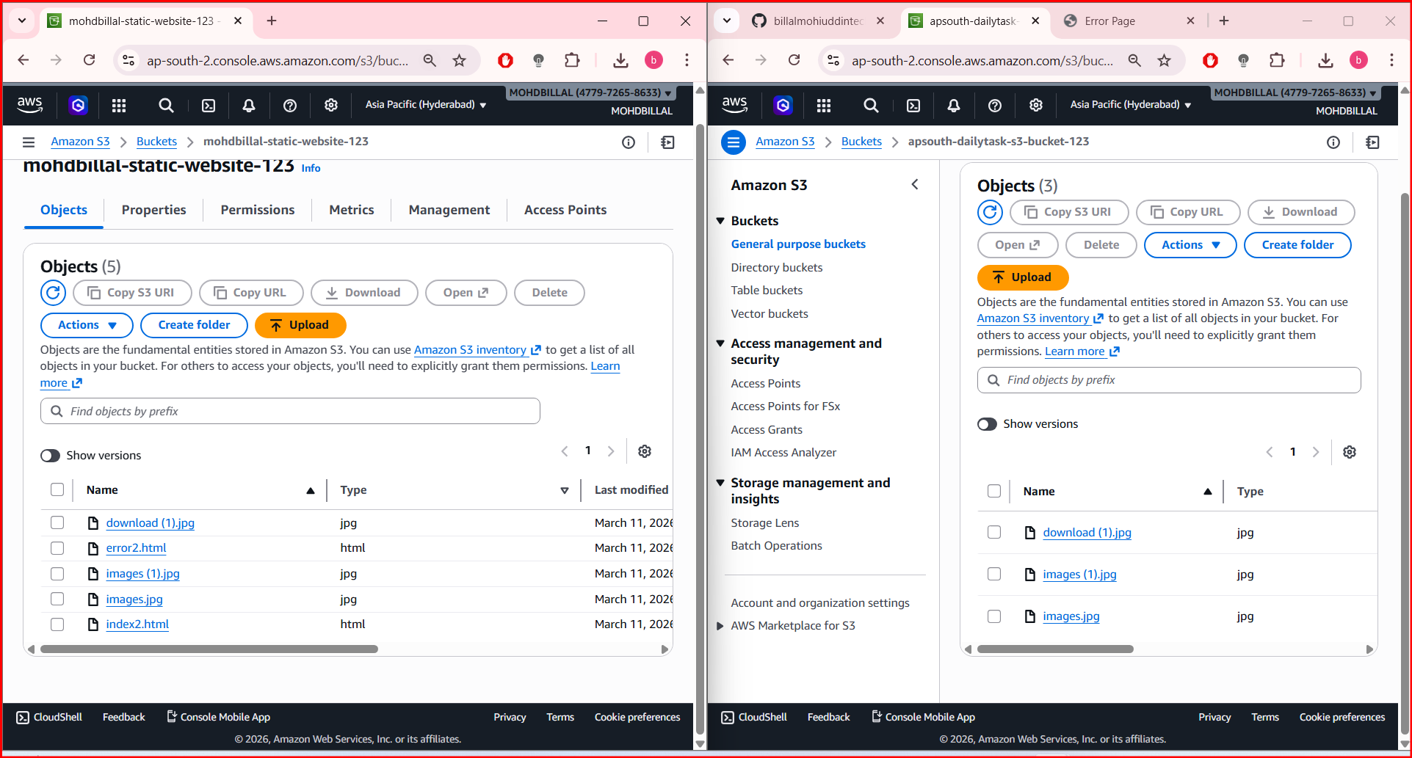
4.Configure a bucket policy so only the Admin user can see the objects of the S3 bucket.

STEP 1. Identify the Admin User ARN
Go to AWS Identity and Access Management → Users → Select Admin.
Copy the ARN. Example:
arn:aws:iam::477972658633:user/MOHAMMED
You will use this ARN in the bucket policy.

STEP 2 Open the S3 Bucket Policy
- Go to Amazon S3.
- Open your bucket.
- Go to Permissions tab.
- Click Bucket Policy → Edit.

STEP 3 Add the Bucket Policy
Replace the Account ID and Bucket Name.
{
"Version": "2012-10-17",
"Statement": [
{
"Sid": "AllowAdminAccessOnly",
"Effect": "Allow",
"Principal": {
"AWS": " arn:aws:iam::477972658633:user/MOHAMMED "
},
"Action": [
"s3:ListBucket",
"s3:GetObject"
],
"Resource": [
"arn:aws:s3::: mohdbillal-static-website-123 ",
"arn:aws:s3::: mohdbillal-static-website-123 /*"
]
}
]
}

STEP 4 Save the Policy
Click Save changes.
Now:
✅ Admin user can see and access objects
❌ Other users cannot access the bucket
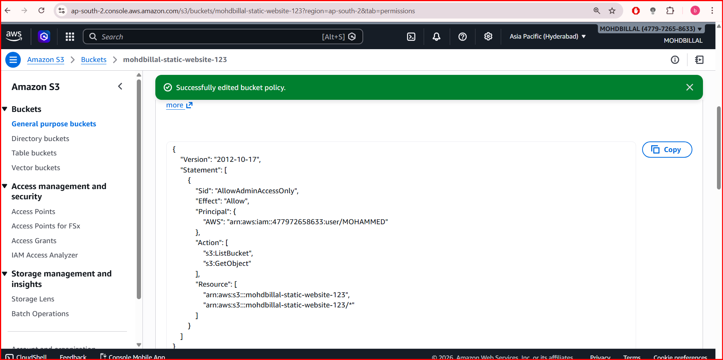
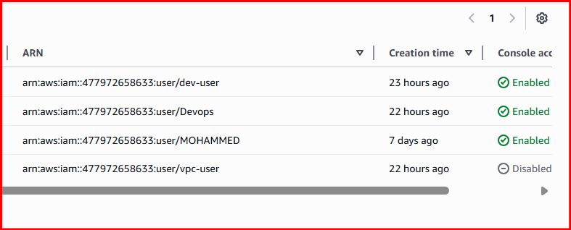

- Set up lifecycle policies to automatically transition or delete objects based on specific criteria.

Steps to Configure Lifecycle Policy

STEP 1.Open the S3 Bucket
- Go to Amazon S3.
- Select your bucket.
- Go to Management tab.

STEP 2. Create Lifecycle Rule
- Click Lifecycle rules.
- Click Create lifecycle rule.
Enter rule name:
auto-archive-rule

STEP 3.Choose Scope
You can apply the rule to:
- All objects in bucket
or
- Objects with prefix (example: logs/)
Example:
Prefix: logs/
This means the rule applies only to files inside the logs folder.

STEP 4. Configure Transition Rules
Enable Transition current versions of objects.
Example configuration:
After | Storage Class
30 days | Standard-IA
60 days | Glacier
Storage classes used in Amazon S3:
- S3 Standard
- S3 Standard-IA
- S3 Glacier
- S3 Glacier Deep Archive

STEP 5.Configure Expiration Rule
Enable Expire current versions of objects.
Example:
Delete objects after: 365 days
This automatically deletes old files.

STEP 6. Save the Rule
Click Create rule.
Your lifecycle automation is now active.

Example Lifecycle Flow
Day 0 → Upload object
Day 30 → Move to Standard-IA
Day 60 → Move to Glacier
Day 365 → Delete object
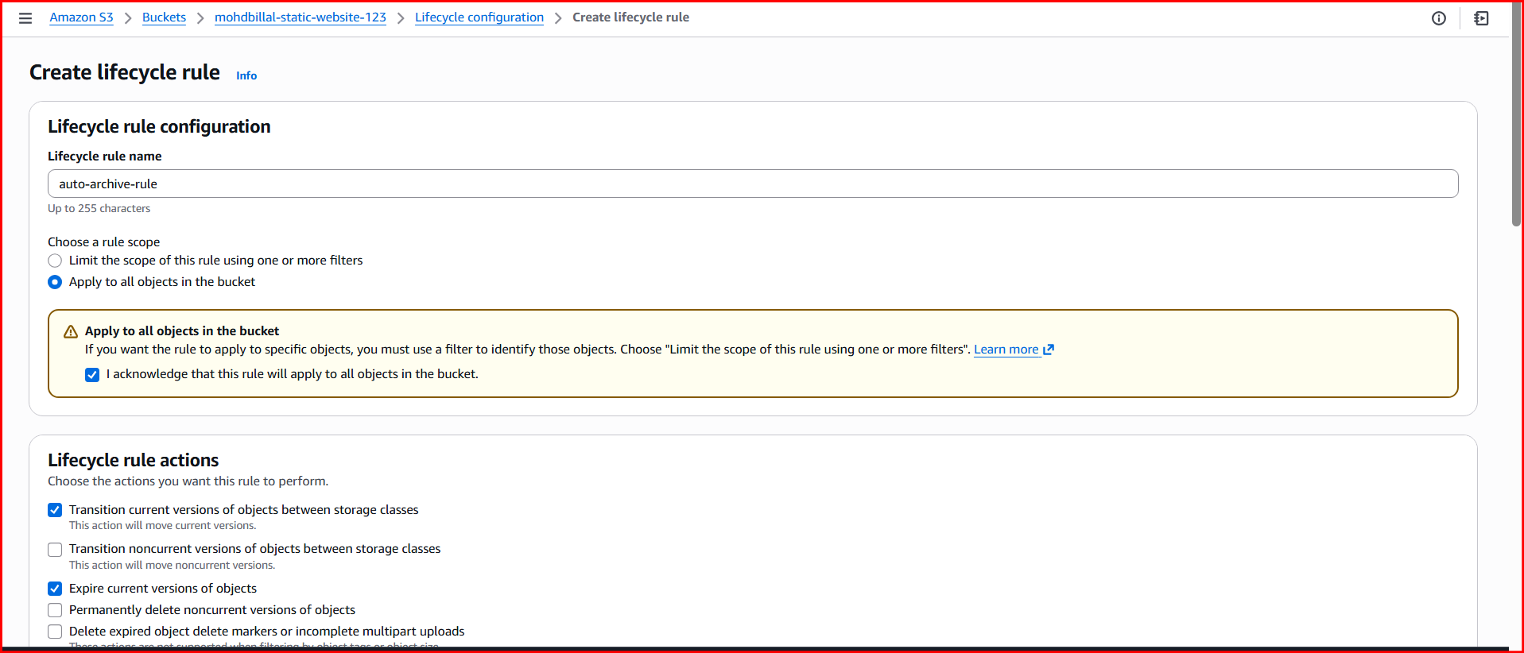
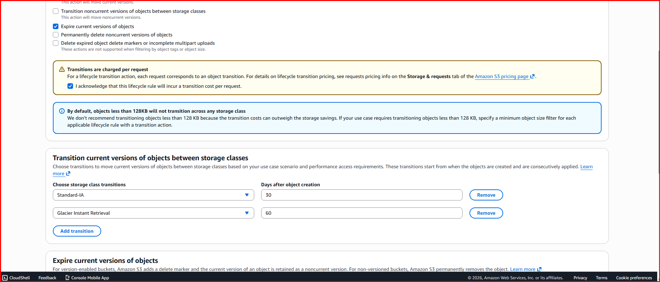
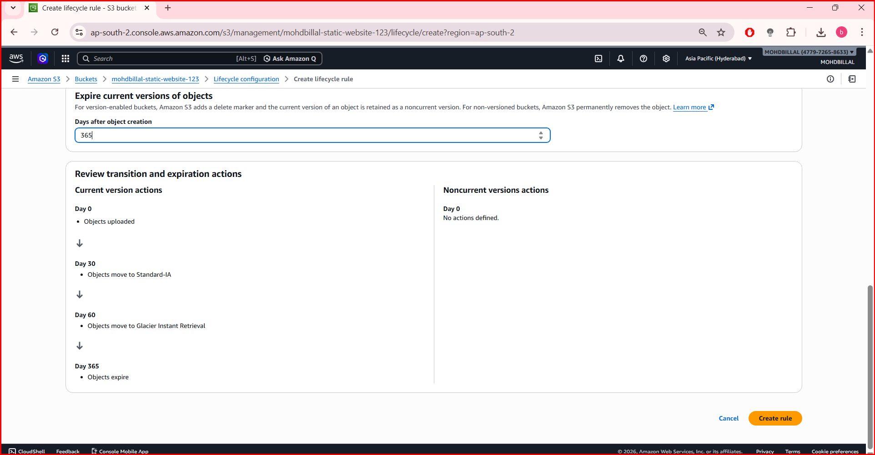
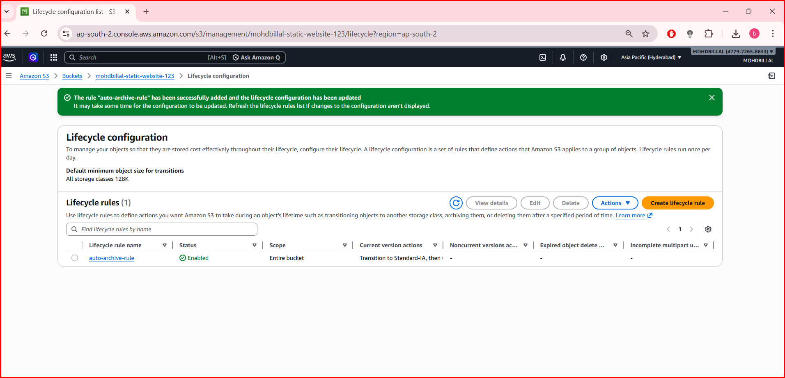

6. Push some objects to S3 using the AWS CLI.

STEP 1:Install AWS CLI
Check if CLI is installed:
aws --version
Example output:
aws-cli/2.x Python/3.x
If not installed, install the AWS CLI.

STEP 2: Configure AWS CLI
Run:
aws configure
Enter your credentials:
AWS Access Key ID: XXXXX
AWS Secret Access Key: XXXXX
Default region name: ap-south-1
Default output format: json
These credentials come from AWS Identity and Access Management.

STEP 3:Upload a Single File to S3
Command:
aws s3 cp file1.txt s3://your-bucket-name/
Example:
aws s3 cp file1.txt s3://my-demo-bucket/

STEP 4: Upload Multiple Files
aws s3 cp image.png s3://my-demo-bucket/
aws s3 cp data.csv s3://my-demo-bucket/

STEP 5:Upload a Folder to S3
Use the recursive option:
aws s3 cp myfolder/ s3://my-demo-bucket/ --recursive
Example folder:
myfolder/
index.html
style.css
app.js
All files will upload to the bucket.

STEP 6: Verify Objects in S3
List files in the bucket:
aws s3 ls s3://my-demo-bucket/
Example output:
2026-03-11 14:20:11 file1.txt
2026-03-11 14:20:20 image.png
2026-03-11 14:20:30 data.csv
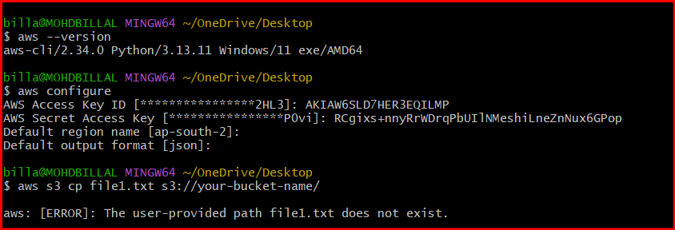
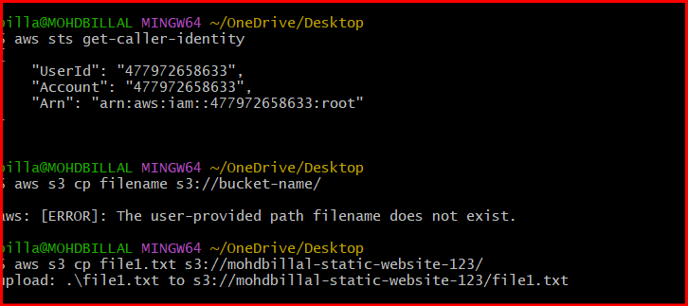
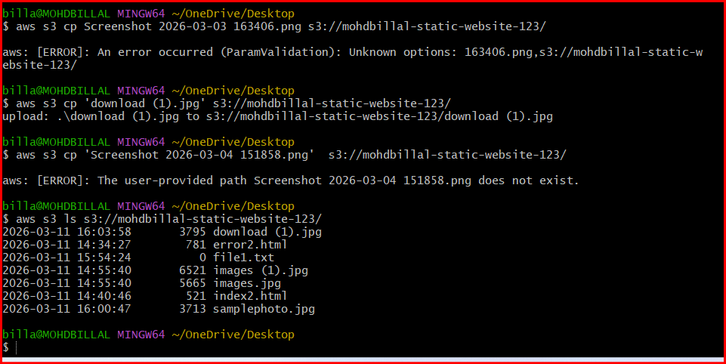
7. Write a Bash script to create an S3 bucket.

Bash Script to Create an S3 Bucket
#!/bin/bash
# Bucket name
BUCKET_NAME="mohdbillal-static-website-123"
# Region
REGION="ap-south-1"
# Create bucket
aws s3api create-bucket \
--bucket $BUCKET_NAME \
--region $REGION \
--create-bucket-configuration LocationConstraint=$REGION
echo "S3 bucket $BUCKET_NAME created successfully"

Steps to Run the Script

Step:1 Create the script file
nano create_bucket.sh
Paste the script and save.

Step:2 Give execute permission
chmod +x create_bucket.sh

Step:3 Run the script
./create_bucket.sh

Verify the Bucket
List all buckets in Amazon S3:
aws s3 ls
Example output:
2026-03-11 15:10:20 my-demo-bucket-12345

DevOps Best Practice Version (Dynamic Bucket Name)
Because S3 bucket names must be globally unique, you can add a timestamp.
#!/bin/bash
BUCKET_NAME="devops-bucket-$(date +%s)"
REGION="ap-south-1"
aws s3api create-bucket \
--bucket $mohdbillal-static-website-123\
--region $REGION \
--create-bucket-configuration LocationConstraint=$REGION
echo "Bucket $BUCKET_NAME created"
This creates buckets like:
devops-bucket-1710151234

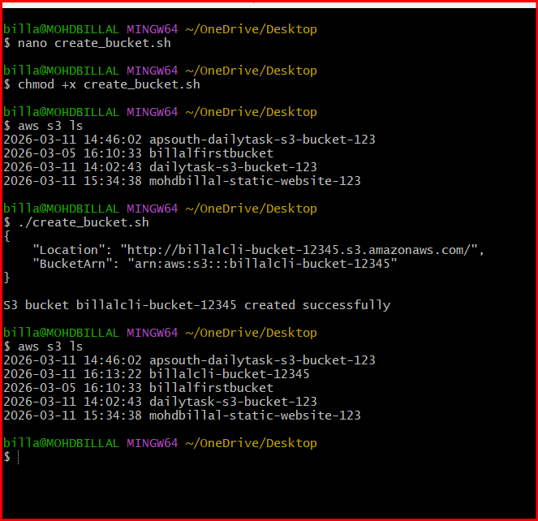
- Upload a 1 GB file to S3 using the CLI.

Step 1:Create a 1 GB Test File

Linux / EC2
dd if=/dev/zero of=1GBfile.bin bs=1M count=1024
Explanation:
- bs=1M → block size = 1 MB
- count=1024 → 1024 MB = 1 GB
Check the file:
ls -lh
Example output:
-rw-r--r-- 1 ec2-user ec2-user 1.0G 1GBfile.bin

Step 2: Upload the File to S3
Run:
aws s3 cp 1GBfile.bin s3://your-bucket-name/
Example:
aws s3 cp 1GBfile.bin s3://my-demo-bucket/
Output example:
upload: ./1GBfile.bin to s3://my-demo-bucket/1GBfile.bin

Step 3: Verify the Upload
List files in the bucket:
aws s3 ls s3://my-demo-bucket/
Example output:
2026-03-11 15:20:12 1073741824 1GBfile.bin

Step 4: Important Note (Large File Upload)
When uploading large files, Amazon S3 automatically uses Multipart Upload, which:
- Splits the file into parts
- Uploads them in parallel
- Improves speed and reliability

